https://ssl.gstatic.com/ui/v1/icons/mail/profile_mask2.png  
[https://ci6.googleusercontent.com/proxy/184hAkpqVA4HmxrB2p8Q1LP2y47j6dQCwDyrq5KJiegIpB4YDqBnZ0pDAdmXDbiXG-QqqYLYdDUBUN7p2QqI83gtgOD7fXvR=s0-d-e1-ft#https://smartinternz.com/assets/logo/smartinternz.png](https://smartinternz.com/)

Dear Student,

Greetings from Smartinternz,

You have successfully joined a team. Please find your team details below:

**Team ID :** LTVIP2023TMID11579

**Team Leader :** N KARTHIK

### Creation Of Semester Object For Candidate Internal Result Card

1. Click on the gear icon and then select Setup.

2. Click on the object manager tab just beside the home tab.

3. After the above steps, have a look on the extreme right you will find a Create Dropdownclick on that and select Custom Object.

4. On the Custom Object Definition page, create the object as follows:

5. Label: Semester

6. Plural Label: Semesters

7. Record Name: Semester Name

8. Check the Allow Reports

9. Check the Allow Search

10.Click Save.

In the same way create **4**more objects as **Candidate**, **Course Details**, **Lecturer Details** and **Internal results**.

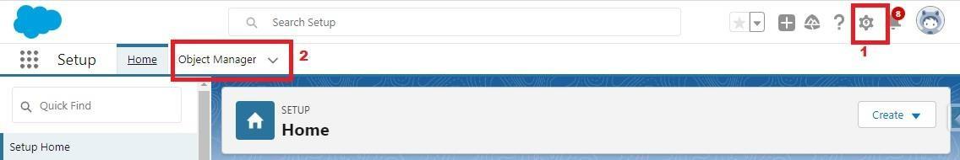

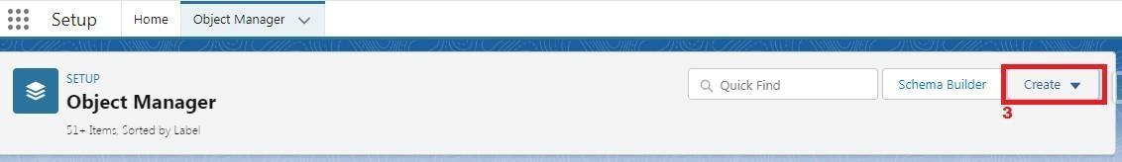

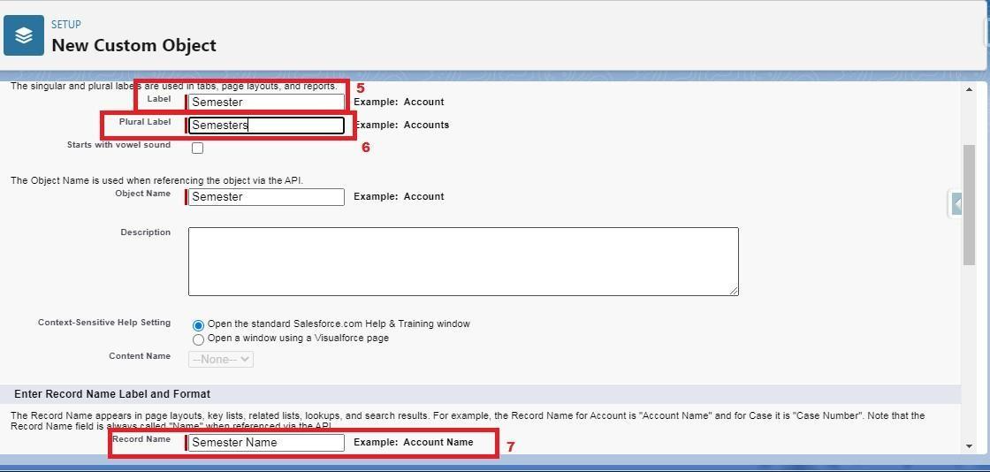

**Creation Of Semester Tab For Candidate Internal Result Card**

Now create a custom tab. Click the Home tab.

1. Enter Tabs in Quick Find and select Tabs.

2. Under Custom Object Tabs, click New.

3. For Object, select Semester.

4. For Tab Style, select any icon.

5. Leave all defaults as is. Click Next, Next, and Save

6. In the same way create Tabs for all Custom Objects -Candidate, Course Details, Lecturer Details, Internal results .

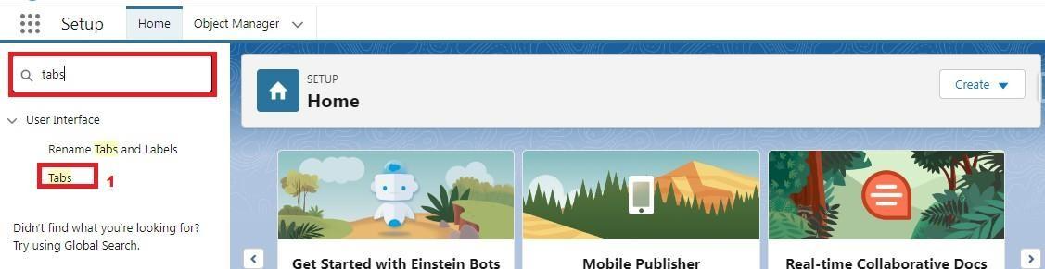

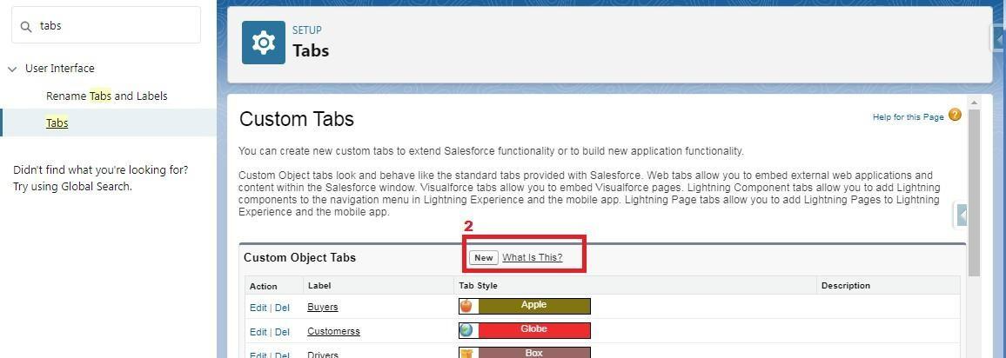

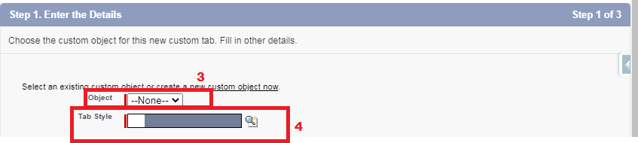

**Create The Candidate Internal Result Card App**

1. From Setup, enter App Manager in the Quick Find and select App Manager.

2. Click New Lightning App.

3. Enter **Candidate Internal Result Card** as the App Name, then click next

4. Under App Options, leave the default selections and click next.

5. Under Utility Items, leave as is and click Next.

6. From Available Items, select **Semester**, **Candidate**, **Course Details**, **Lecturer Details**, **Internalresults**, **Reports**, and **Dashboards** and move them to Selected Items.

7. Click Next.

From Available Profiles, select System Administrator and move it to Selected Profiles. Click Save & Finish.

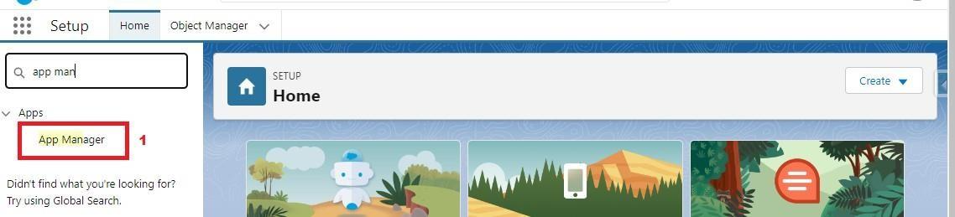

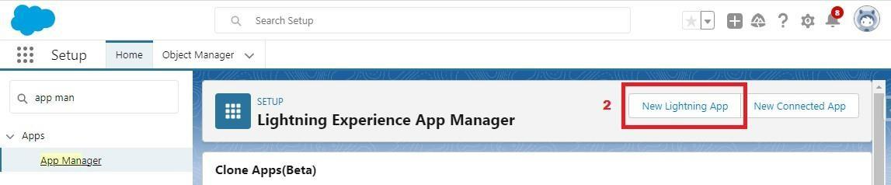

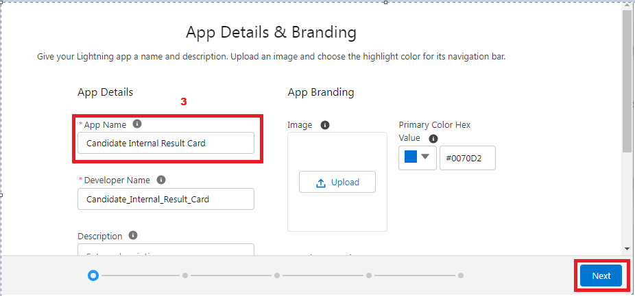

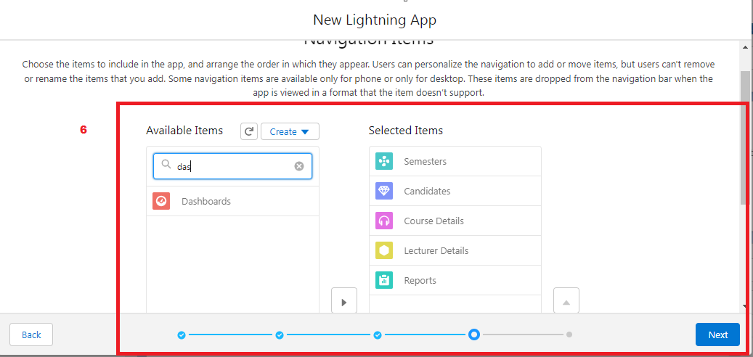

**Creation Of Text Field On "Lecturer Details" & Look Up Field For The “Candidate” Object**

1.Click the gear icon and select Setup. This launches Setup in a new tab.

2. Click the Object Manager tab next to Home.

3. Select Lecturer Details

4. Select Fields & Relationships from the left navigation

5. Click New

6. Select the Text as the Data Type, click next.

7. For Field Label, enter Lecturer Role

8. Enter Length 40

9. Click Next, Next, then Save & New.

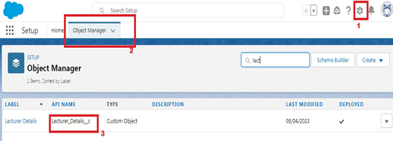

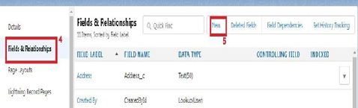

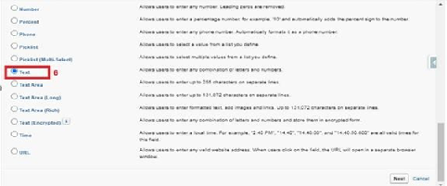

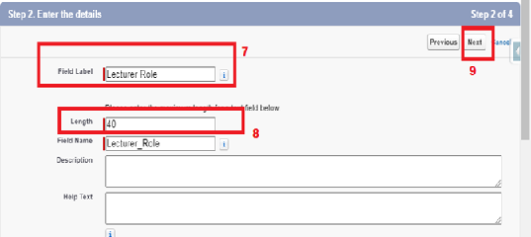

Now Let’s create a Lookup field on candidate object

1. Click the gear icon and select Setup. This launches Setup in a new tab.

2. Click the Object Manager tab next to Home.

3. Select candidate.

4. Select Fields & Relationships from the left navigation

5. Click New

6. Select the lookup as the Data Type, then click Next.

7. In related select Semester

8. For Field Label Semester Name, enter.

9. Click Next, Next, then Save & New.





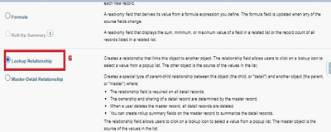

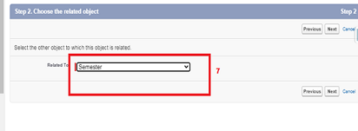

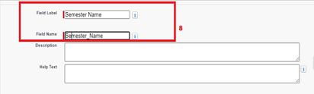

Note- Similarly create all lookup fields on their respective objects.

**Creation Of Auto Number Field On Candidate Object, Number Field On Course Details Object & Formula Field Course Details Object**

Let’s create a Number field on Course Details object

1. Click the gear icon and select Setup. This launches Setup in a new tab.

2. Click the Object Manager tab next to Home.

3. Select Course Detail.

4. Select Fields & Relationships from the left navigation

4. Click New & select number field, click Next

6. For Field Label Duration, enter.

7. Give Help Text- Enter Course duration value in Years

8. Click Next, Next, then Save & New.





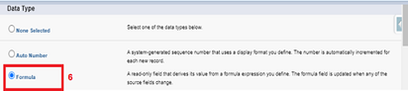

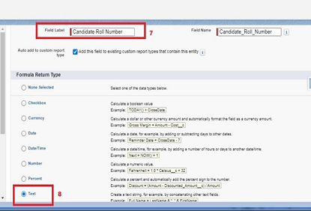

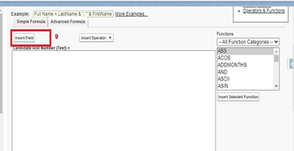

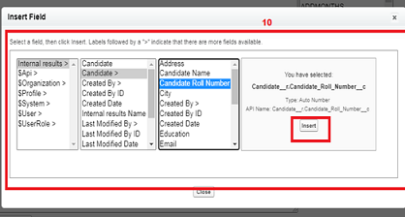

Now Let’s create an auto number field on Candidate object

1. Click the gear icon and select Setup. This launches Setup in a new tab.

2. Click the Object Manager tab next to Home.

3. Select Candidate.

4. Select Fields & Relationships from the left navigation

5. Click New

6. Select the Auto Number as the Data Type, then click Next.

7. For Field Label Candidate enter Roll Number.

8. Give a display format

9. Click Next, Next, then Save & New.





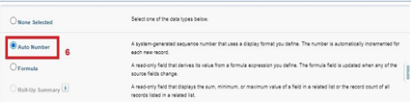

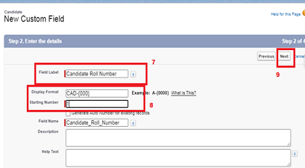

**Creation Of Auto Number Field On Candidate Object, Number Field On Course Details Object & Formula Field Course Details Object**

Let’s create a Number field on Course Details object

1. Click the gear icon and select Setup. This launches Setup in a new tab.

2. Click the Object Manager tab next to Home.

3. Select Course Detail.

4. Select Fields & Relationships from the left navigation

4. Click New & select number field, click Next

6. For Field Label Duration, enter.

7. Give Help Text- Enter Course duration value in Years

8. Click Next, Next, then Save & New.





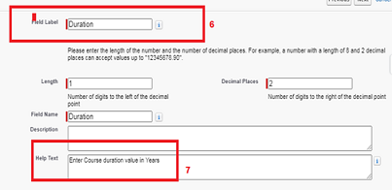

Now Let’s create a Formula field on Internal Results object

1. Click the gear icon and select Setup. This launches Setup in a new tab.

2. Click the Object Manager tab next to Home.

3. Select Internal results.

4. Select Fields & Relationships from the left navigation.

5. Click New

6. Select the Formula as the Data Type, then click Next.

7. Give field label Candidate Roll Number

8. Select formula return type text, Click Next

9. Click Insert Field

10.Create and insert formula Candidate r.Candidate_Roll_Number   c, and then click Insert.

11.Click Next, Next, then Save.













Now Let’s create an auto number field on Candidate object

1. Click the gear icon and select Setup. This launches Setup in a new tab.

2. Click the Object Manager tab next to Home.

3. Select Candidate.

4. Select Fields & Relationships from the left navigation

5. Click New

6. Select the Auto Number as the Data Type, then click Next.

7. For Field Label Candidate enter Roll Number.

8. Give a display format

9. Click Next, Next, then Save & New.







